Chara Kolokytha

Cubism

Cubism is an influential modernist art movement that emerged in Paris during the first decade of the twentieth century. The term was established by Parisian art critics, derived from Louis Vauxcelles, and possibly Henri Matisse’s description of Braque’s reductive style in paintings of 1908. Subsequently, it soon became a commonplace term and was widely used to describe the formalist innovations in painting pioneered by Pablo Picasso and Georges Braque from 1907 to 1914. Cubism signals the break with Renaissance tradition through the rejection of three-dimensional illusionist composition. The dull and monochromatic palette (Picasso, Still Life with a Bottle of Rum, 1911) of early Cubist painting, in addition to its emphasis on geometry, can be alternatively viewed as a reaction against the pure bright colours of the Fauves and the spontaneous colour treatment of the Impressionists. Cubist art was largely influenced by the late work of Paul Cézanne and the study of primitive art and, more precisely, African religious masks, statuettes and artefacts. Picasso’s Les Demoiselles d’Avignon (1907) and Braque’s Maisons à l’Estaque (1908) are considered to be the first manifestations of proto-cubist painting.

However, artists such as Fernand Léger (Les fumeurs, 1912), Juan Gris (Grapes, 1913) and Robert Delaunay (Windows, 1912) developed their own distinctive styles, pushing forward the colour perspectives, the shifting geometrical elements and the non-objective approach (Léger, Contraste de formes, 1913) of the cubist synthesis. Alternative cubist perspectives were also introduced by painters such as Jean Metzinger, Albert Gleizes, Henri Le Fauconnier, Roger de La Fresnaye, André Lhote, and sculptors such as Jacques Lipchitz and Henri Laurens. Its influence was not limited to painting and sculpture but extended to architecture, poetry, music, literature and the applied arts.

Conceptual and Perceptual Cubism

Cubism gained worldwide recognition from the second decade of the twentieth century onwards. However, it expanded and evolved rapidly in Paris so that a large number of Cubist-influenced styles emerged that differ substantially to that of Picasso and Braque. This variation mainly resides in the perceptual, either quasi-figurative (Lhote, L'Escale, 1913) or purely abstract cubist perspective that several artists brought forward (Delaunay, Fenêtres ouvertes simultanément, 1912). In addition to the emphasis on solid geometry, their vivid colour palette replaced the proto-cubist perpetual use of greys, browns and blacks and opposed its simplified geometrical surfaces that are divided into plastic planes viewed from different angles and result in the conceptual perspective of early cubism (La Fresnaye, The Conquest of the Air, 1913).

In fact, the style was never homogenous but raised controversy among its agents. This became evident in 1911, with the occurrence of the so-called Puteaux Group (1911-1913) of Cubist artists, including Alexander Archipenko, Gleizes, Metzinger, Frank Kupka, Marcel Duchamp and Léger, who frequented the studios of Jacques and Raymond Duchamp-Villon. The group’s art can be viewed as a reaction against the conceptual and non-humanitarian approach of Picasso, Braque, and Gris. A similar reaction is manifested in the works of several other artists such as Lhote and La Fresnaye who practised a perceptual and quasi-figurative style.

Although most of these artists taught Cubism in private art academies and had exhibited their compositions since 1911 at the Salon des Indépendants and the Salon d’Automne, the generators and leaders of this style (Picasso, Braque, Gris, Léger) were working in private under the patronage of the art dealer Daniel Henri Kahnweiler. Clearly, this fact not only contributed to the popularisation of the perceptual and the geometrically abstract cubist technique in the following decades, but also reflects the over-simplified and legible repertoire of most of these artists in opposition to the constant experimentation and renovation of Kahnweiler’s protégés.

Analytic and Synthetic Cubism

Due to its complexity, Cubism became subject to several formal and stylistic categorizations and even philosophical interpretations. Its division into the two phases ‘Analytic’ and ‘Synthetic’ has been widely used, although it is chronologically flexible and has been questioned by scholarship because it was not literally accepted by cubist artists. This division was introduced later by Kahnweiler who proposed to better explain and classify the stylistic experimentations and developments of this style. Both phases include the work of Picasso and Braque.

Analytic cubism, also referred to as ‘Hermetic cubism’, is a term used to describe the early achievements of the cubist stylistic innovations and extends approximately from 1910 to 1912. It concerns the simultaneous depiction on a two dimensional surface of several sides of a three dimensional object-subject (Picasso, Portrait of D.-H. Kahnweiler, 1910). Although this technique may be seen as abstract it is, in reality, essentially figurative but aims to re-treat and re-interpret the conventional composition (Braque, Portuguese, 1911). Therefore, the depicted objects are mainly still lives that tend to become easily recognisable as they draw inspiration from everyday life (bottles, tables, musical instruments, books, newspapers) often accompanied by letters or words that describe them (Braque, Clarinet and bottle of rum on a mantelpiece, 1911).

Synthetic cubism extended from 1912 to 1914 and introduced the collage technique, the use of vivid colours and different types of materials, mainly paper (wall-paper, papiers collés, paper cut-outs, textiles), that contribute to the maintenance of the solid structure of the composition and render it legible through the creation of an architectonic illusion of space and volume (Picasso,
Still Life with Chair-caning, 1912). This phase exerted considerable influence over the surrealist treatment of the object.

List of Works

Pablo Picasso, Les Demoiselles d’Avignon (The young ladies of Avignon), oil on canvas, 1907, Museum of Modern Art, New York.

Georges Braque, Maisons à l’Estaque (Houses at l’Estaque), oil on canvas, 1908, Museum of Fine Arts, Bern.

Picasso, Portrait of Daniel-Henri Kahnweiler, oil on canvas, 1910, Art Institute of Chicago.

Braque, Clarinet and bottle of rum on a mantelpiece, oil on canvas, 1911, Tate Gallery, London.

Georges Braque, Portuguese, oil on canvas, 1911, Kunstmuseum Basel, Basel, Switzerland.

Pablo Picasso, Still Life with a Bottle of Rum, oil on canvas, 1911, The Metropolitan Museum of Art, New York.

Fernand Léger, Les fumeurs (The Smokers), oil on canvas, 1912, Solomon R. Guggenheim Museum, NewYork.

Robert Delaunay, Windows, oil and wax on canvas, 1912, Museum of Modern Art, New York.

Fernand Léger, Contraste de formes (Contrast of forms), oil on canvas, 1913, Solomon R. Guggenheim Museum, NewYork.

Picasso, Still Life with Chair-caning, oil on oil-cloth over canvas edged with rope, 1912, Musée Picasso, Paris.

Robert Dealaunay, Fenêtres ouvertes simultanément (Windows open simultaneously), 1912, Tate Gallery, London.

André Lhote, L'Escale (The layover), oil on canvas, 1913, Musée d'art Moderne de la Ville de Paris.

Juan Gris, Grapes, oil on canvas, 1913, Museum of Modern Art, New York.

Roger de la Fresnaye, The Conquest of the Air, oil on canvas, 1913, Museum of Modern Art, New York.

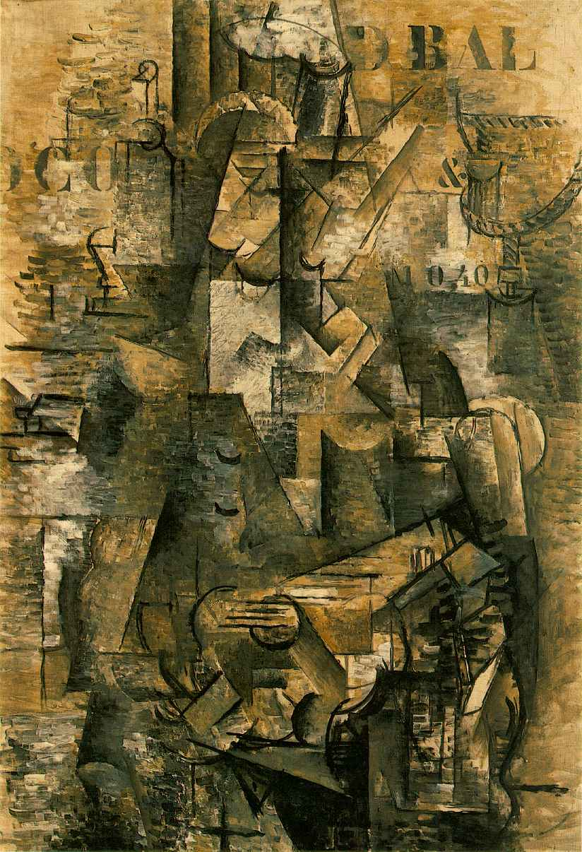

Georges Braque, Portuguese, oil on canvas, 1911, Kunstmuseum Basel, Basel, Switzerland.

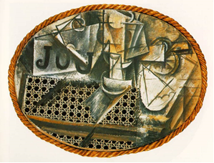
Picasso, Still Life with Chair-caning, oil on oil-cloth over canvas edged with rope, 1912, Musée Picasso, Paris.
http://lukerobinson.pushinit.co.uk/wp-content/uploads/2011/04/chaircan.jpg

References and further reading

Golding, J. (1959) Cubism: a history and an analysis, 1907-1914, London, Faber&Faber.

Fry, E. (1966), Cubism, New York, McGraw-Hill.

Gee, M. (1981) Dealers, critics, and collectors of modern painting: aspects of the Parisian art market between 1910 and 1930, New York; London, Garland.

Cooper, D. (1983) The essential Cubism, 1907-1920: Braque, Picasso and their friends, London, Tate Gallery.

Roskill, M. W. (1985), The interpretation of cubism, Philadelphia, Art Alliance Press.

Green, C. (1987) Cubism and its enemies: modern movements and reaction in French art, 1916-1928, New Haven, Yale University Press.

Rubin, W. S. (1989), Picasso and Braque: pioneering cubism, New York, Museum of Modern Art.

Cox, N. (2000), Cubism, London, Phaidon.

Cottington, D. (2004), Cubism and its histories, Manchester; New York, Manchester University Press.

Antliff, M., Leighten, P. D. (2008) A Cubist reader: documents and criticism, 1906-1914, Chicago, University of Chicago Press.

